Assingment—5

NAME: G.Siddhartha Reddy Roll.no: 2503a52368
Batch no: 13

Task Description #1 (Privacy in API Usage)
Prompt: Generate code to fetch weather datasecurely withoutexposing APIkeys in the code.

Code:
import os importrequests

api_key = os.getenv("WEATHER_API_KEY")
url = f"http://api.openweathermap.org/data/2.5/weather?q=LondonCappid={api_key}" response = requests.get(url)
if response.status_code == 200:
data = response.json() print(data)
else:
print(f"Erro r fetching data: {respo nse.status_co de}")

output:
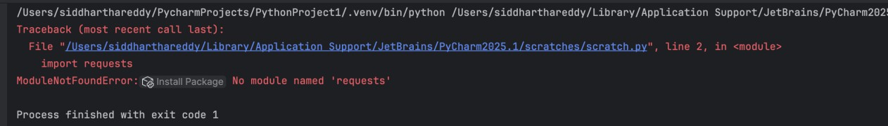

Task Description #2 (Privacy samp; Security in File Handling)
Task: Use an AI tool to generate a Python script that stores user data(name, email, password) in a file.
Prompt: generate a Python script that stores user data(name, email, password) in a file.

Code:
import base64 import hashlib import json import secrets
from pathlib import Path

USER_FILE = Path("users.json")

def hash_password(password: str) -> tuple[str, str]:
"""Return a unique salt and a slow, one-way password hash.""" salt = secrets.token_bytes(16)
password_hash = hashlib.pbkdf2_hmac(
"sha256", password.encode("utf-8"), salt, 600_000
)
return (
base64.b64encode(salt).decode("ascii"), base64.b64encode(password_hash).decode("ascii"),
)

def save_user(name: str, email: str, password: str) -> None:

salt, password_hash = hash_password(password) user = {
"name": name, "email": email,
"password_hash": password_hash, "password_salt": salt,
}
USER_FILE.write_text(json.dumps(user, indent=2), encoding="utf-8")

def main() -> No ne:
name =input("Name: ") email =input("Email: ")
password = input("Password: ") save_user(name, email, password)

print("\nPrivacy analysis:")
print("- Plain-text passwords would allow anyone with the file to log in.") print("- Passwords in logs, backups, orsource code could also be exposed.") print("- This version stores a salted PBKDF2 hash instead of the password.") print(f"\nUser saved securely to {USER_FILE}.") print(USER_FILE.read_text(encoding="utf-8"))

if name == " main ": main()

output:
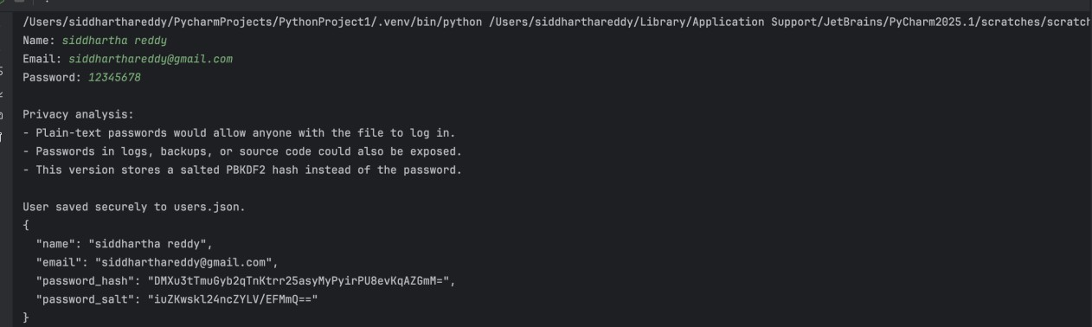

Task Description #3 (Transparency in Algorithm Design)
Prompt: generate an Armstrong number checking function with comments and explanations.

Code:
def is_armstro ng_num be r(n ):
"""
Check if a number is an Armstrong number.

An Armstrong number (also known as a narcissistic number) is a number that is equal to the sum of its own digits raised to the power of the number of digits.

For example:
- 153 is an Armstrong number because 1^3 + 5^3 + 3^3 = 153
- 9474 is an Armstrong number because 9^4 + 4^4 + 7^4 + 4^4 = 9474

Parameters:

n (int): The number to check.

Returns:
bool: True if n is an Armstrong number, False otherwise. """

# Convert the number to a string to easily iterate over each digit digits = str(n)

# Calculate the number of digits num_digits = len(digits)

# Calculate the sum of each digit raised to the power of num_digits armstrong_sum = sum(int(digit) ** num_digits for digit in digits)

# Check if the calculated sum is equal to the original number return armstrong_sum == n
#example usage:
number = 153
if is_armstro ng_numbe r(num be r): print(f"{number} is an Armstrong number.")

output:
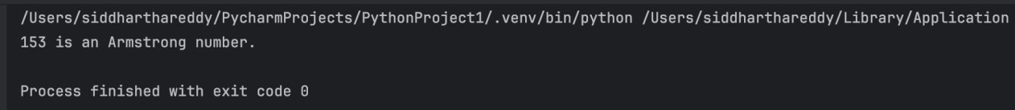

Task Description #4 (Transparency in Algorithm Comparison)
Task: Use AI to implement two sorting algorithms (e.g., QuickSort and BubbleSort).
Prompt:Generate Python code for QuickSort and BubbleSort, and include comments explaining step-by-step how each works and where they differ.

Code:
def quick_so rt(values):
"""Return a sorted copy of *values* using the QuickSort algorithm.

QuickSort chooses a pivot, divides the remaining values into values that are less than or equal to the pivot and values greater than the pivot, then recursively sorts both partitions.
"""
if len(values) <= 1: return values.co py()

pivo t = values[len(values) // 2]
sma ler = [value for value in values if value < pivot] equal = [value for value in values if value == pivot] larger = [value forvalue in values if value > pivot]

return quick_sort(smaller) + equal + quick_sort(larger)

def bubble_so rt(va lues):
"""Return a sorted copy of *values* using the BubbleSort algorithm.

BubbleSortrepeatedly compares neighboring values. If they are in the wrong order, itswaps them. Aftereach pass, the largest unsorted value has "bubbled" to the end of the list.
"""
result = values.copy()

# Each pass checks the portion thathas notalready been sorted. for end in range(len(result) - 1, 0, -1):
swapped = False

# Compare neighboring values from left to right. for index in range(end):
if result[index] > result[index + 1]:
# Swap adjacent values that are out of order. result[index], result[index + 1] = (
result[index + 1], result[index],
)
swapped = True

# Stop early when a complete pass makes no swaps. if not swapped:
break

return result

numbers = [64, 34, 25, 12, 22, 11, 90]

print("Original list: ", numbers) print("QuickSort: ", quick_sort(numbers))
print("BubbleSort: ", bubble_sort(numbers))

# Comparison:
# - QuickSort divides the list around a pivot and usually runs in O(n log n) # time. Its worst case is O(n²), depending on the pivot choices.
# - BubbleSortrepeatedly scans neighboring values and runs inO(n²) time in # the average and worstcases. With the early-stop check, an already sorted # list can be processed in O(n) time.
# - QuickSortis generally fasterforlarge, unsorted lists, while BubbleSort # is simpler to understand and useful for small or nearly sorted lists.

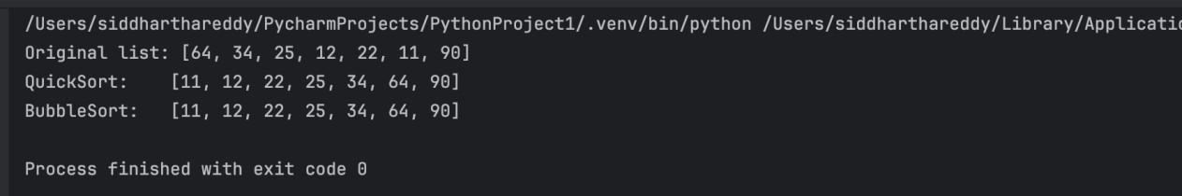
Output:

Task Description #5 (Transparency in AI Recommendations)
Task: Use AI to create a product recommendation system.

Prompt: Generate a recommendation system that also provides reasons for each suggestion.

Code:
from dataclasses import dataclass from typing import List, Set, Tuple

@dataclass(frozen=True) class Product:
name: str category: str price: float features: Set[str] description: str

PRODUCTS = [
Product(
"SoundMax Wireless Headphones", "electronics",
79.99,
{"wireless", "noise cancellation", "bluetooth", "long battery"},
"Comfortable headphones for music, travel, and online classes.",
),
Product(
"FitTrack Smartwatch", "electronics",
99.99,
{"fitnesstracking", "bluetooth", "water resistant", "long battery"}, "A smartwatch fortracking exercise, sleep, and daily activity.",

),
Product(
"ReadPro E-Reader", "electronics", 129.99,
{"wireless", "long battery", "lightweight", "reading"}, "A lightweight e-reader with a glare-free display.",
),
Product(
"ErgoComfort Office Chair", "furniture",
149.99,
{"ergonomic", "adjustable", "comfortable", "back support"},
"An adjustable chair designed for comfortable long work sessions.",
),
Product(
"UrbanTrail Backpack", "bags",
49.99,
{"water resistant", "lightweight", "laptop compartment", "travel"}, "A durable backpack for school, work, and travel.",
),
Product(
"BrewMate Coffee Maker", "kitchen",
59.99,
{"automatic", "programmable", "compact", "easy to clean"},
"A compact programmable coffee maker for home or office use.",

),
]

def recommend_products( preferences: Set[str], budget: float,
catego ry: str = "",
number_of_recommendations: int = 3,
) -> List[Tuple[Pro duct, int, List[str]]]:
"""Return products ranked by preference matches, affordability, and category.""" recommendations = []

for product in PRODUCTS:
if pro duct.price > budget:
continue

matching_features = preferences.intersection(product.features) score = len(matching_features) * 3
reasons = [f"matches your preference for {feature}" for feature in sorted(matching_features)]

if catego ry and pro duct.catego ry.lo wer() == catego ry.lo wer(): score += 2
reasons.append(f"is in your preferred {category.lower()} category")

if no t reaso ns:
reasons.append("fits within your budget")

recommendations.append((product, score, reasons))

return sorted(
recommendations,
key=lambda item: (-item[1], item[0].price),
)[:number_of_recommendations]

def main() -> No ne:
print("=== AI Product Recommendation System ===")
print("Available preferences include: wireless, fitness tracking, ergonomic, travel, and more.")

preferences = { preference.strip().lower()
forpreference ininput("Enteryourpreferences(comma-separated): ").split(",") if preference.strip()
}
budget = float(input("Enter your maximum budget: ")) catego ry = input("Enter a preferred catego ry (o ptio nal): ").strip()

recommendations = recommend_products(preferences, budget, category)

if no t reco mmendatio ns:
print("\nNo products match your preferences and budget.") return

print("\nRecommended products:")
for position, (product, score, reasons) in enumerate(recommendations, start=1):

print(f"\n{po sitio n}. {pro duct.name} - ${pro duct.price:.2f}") print(f" {product.description}")
print(f" Why this is recommended (score {score}):") for reason in reasons:
print(f" - {reason}")

if name == " main ": main()

output:
